**Q1 . SQL LOADER**

1. **MAKE SURE THAT NO EXTRA SPACES**

**AND TRIM DATA**

1. **GENDER SHOULD BE ONLY M OR F**

**CREATION OF NEW TABLE AND COMMIT CHANGES;**

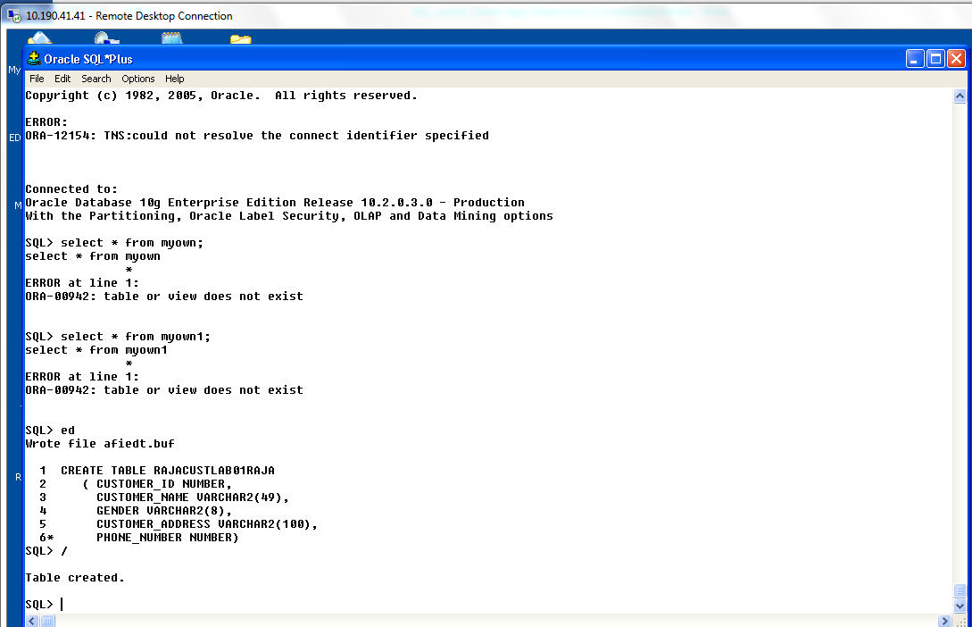

**ADJUSTMENT OF DATA FILE AND SAVE IT AS CUST_MODULE.dat**

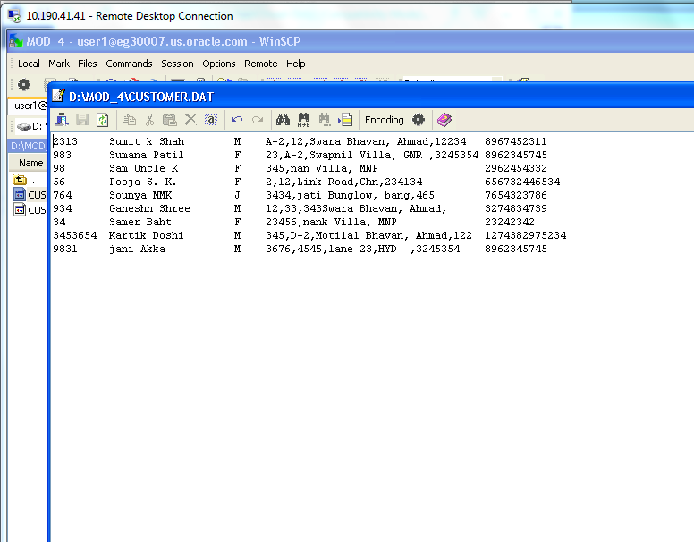

**CREATION OF CTL FILE and SAVE IT AS CUST_MODULE4.ctl**

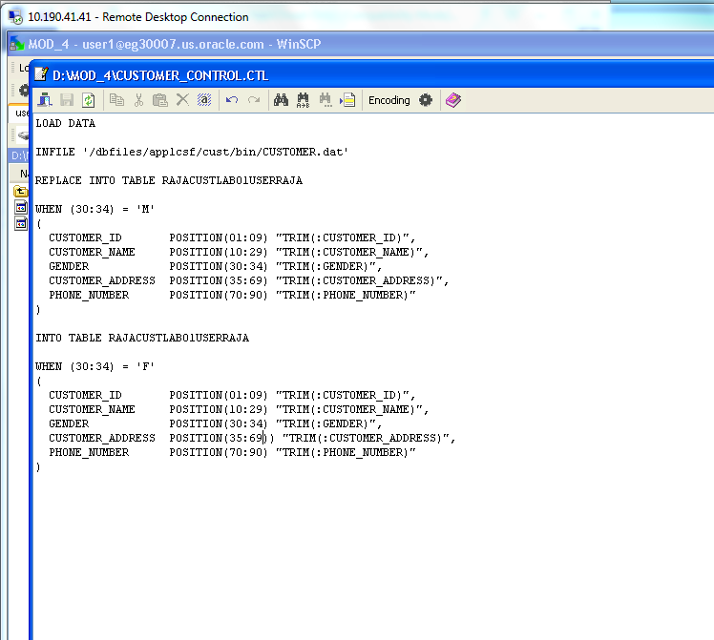

**KEEP FILE INTO THE SERVER USING WINSCP**

**And transfer settings as BINARY;**

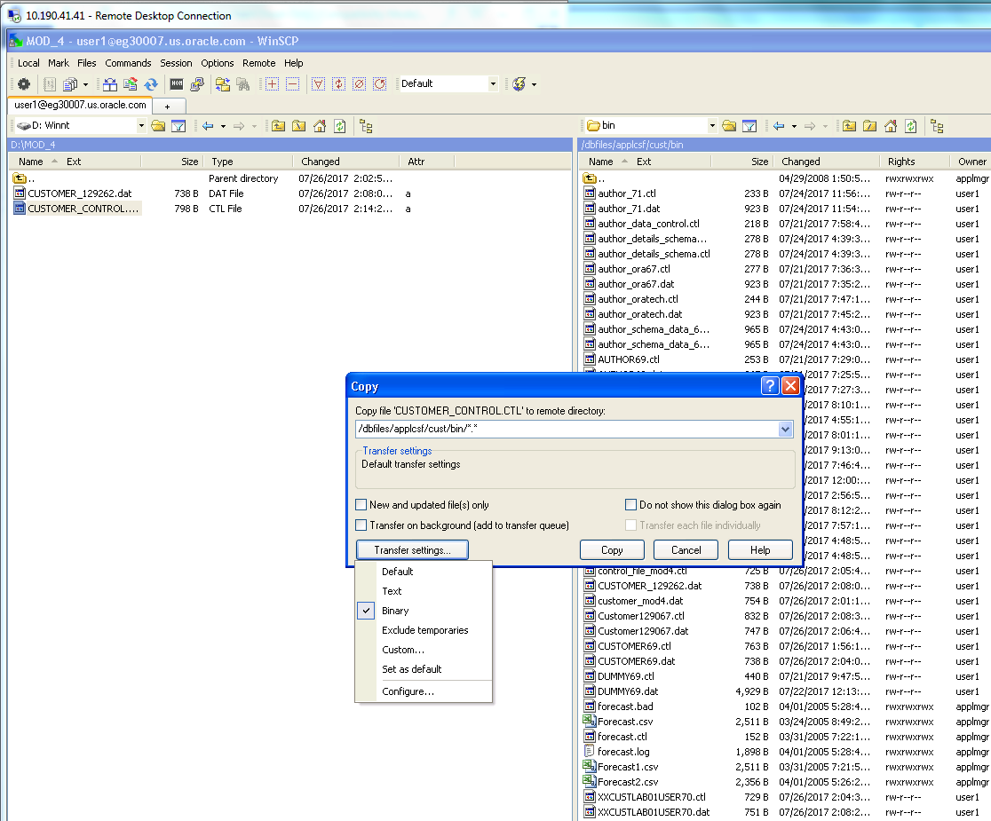

**PLACE IT IN THE EXECUTABLE FORM and save it;**

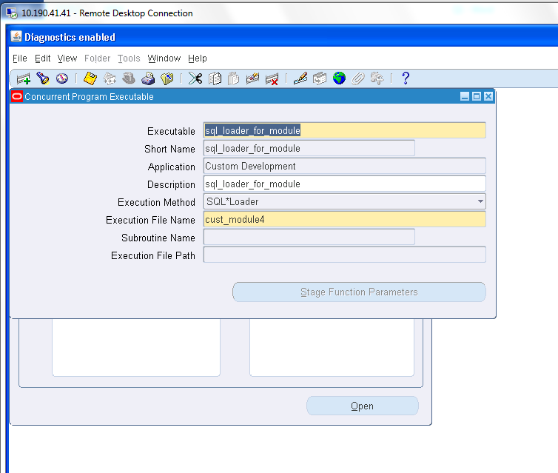

**PLACE IT IN THE PROGRAM FORM**

**And save it;**

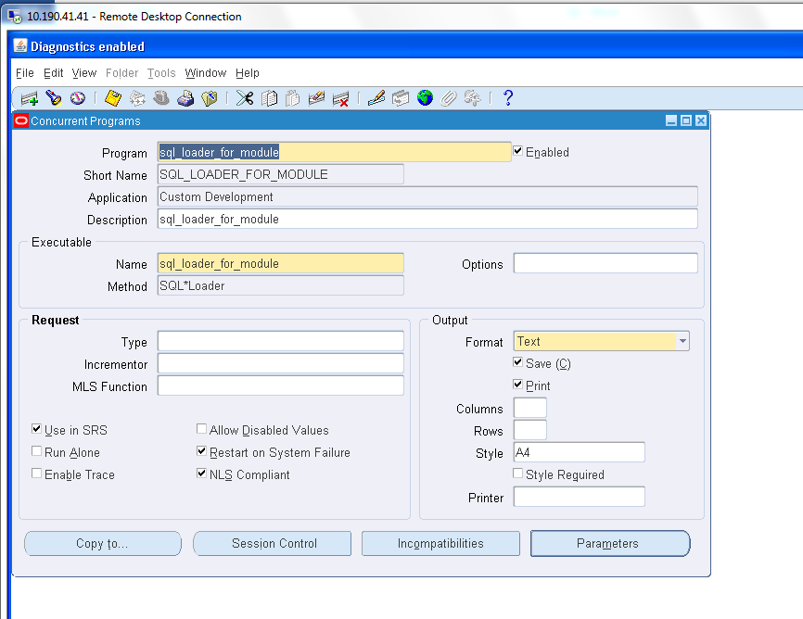

**PLACE IT IN THE GROUP and save it;**

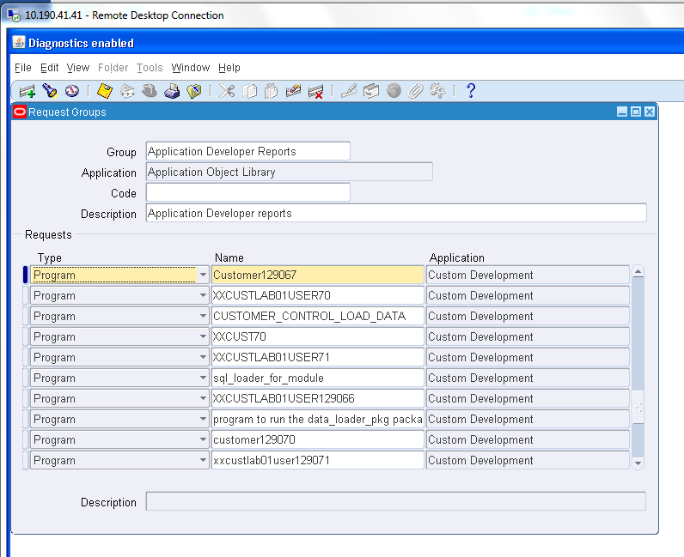

**RUN THE FORM**

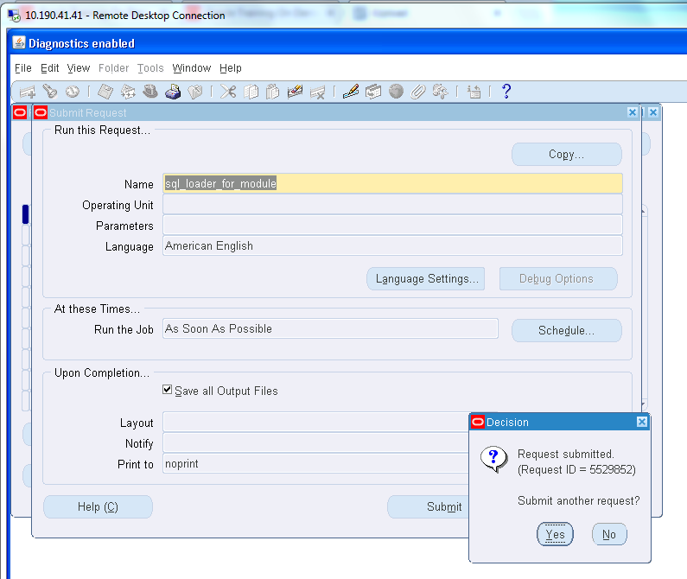

**CHECK LOG FILE**

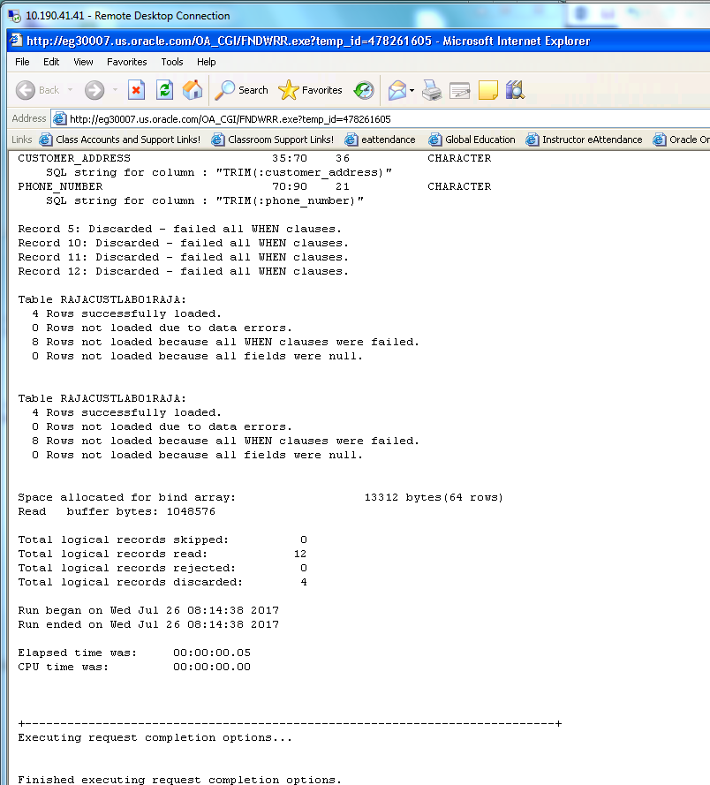

**CHECK THE OUTPUT FILE in the server;**

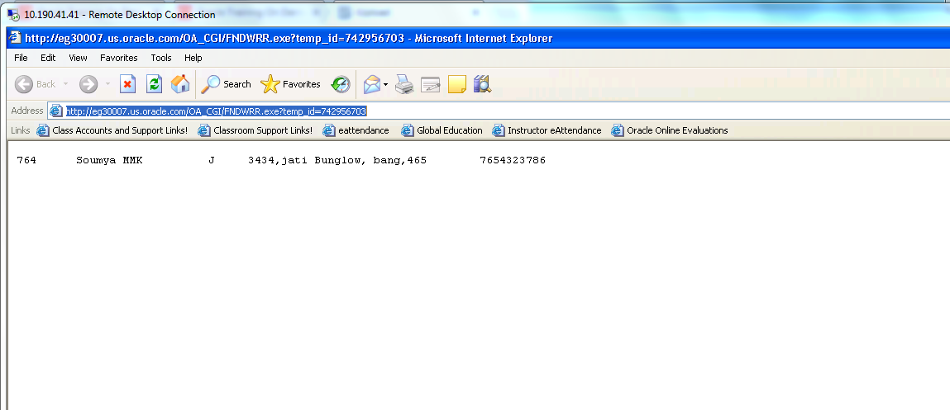

**CHECK THE NUMBER OF RECORDS LOADED IN THE TABLE FROM SQL PLUS**

